# **The Battle of Neighborhoods: Japan Hostels**

1. Introduction

1.1 Background

As someone who loves travelling, finding ways to save money and travel low-cost is essential. There's little to save while booking flights and I'd rather pay more to traveling comfortably on a 16Hr flight than try to save and wear myself down even before the trip begins! But we can always save a few bucks on accommodation.

A hostel is a low-budget accommodation shared among travellers. Staying at hostels is an extremely affordable option for travellers. Not only that, It also gives you a chance to experience which you would never at a hotel. I've found that experiencing hostel life one of the best ways to travel the world on a budget and here’s why:

1. You'll save a lot of money trust me.

2. Meet other like-minded travellers and make new friends around the world!

3. Most hostels organize lot of social activates

1.2 Business Understanding/Problem Description

Hostel accommodation is a booming industry with the latest rise in tourism worldwide, especially in Asia. Over 20% of the total tourists worldwide are aged between 19-25. And around 80% of them prefer to spend less on accommodation by opting for hostels. This means the demand for hostels is only going to grow further and more people would want to get their legs in the game.

* How should a new business person decide where to open a hostel?
* What factors should he look at before investing?
* Which neighborhood venues affect a user's rating for location of hostel?

At the same time, it is difficult for a travellers, especially first-timers, to select a hostel from among many options. Hostel reviews are subjective and differ from person-to-person and one cannot solely depend on them to make a decision. It is especially important to consider other aspects like price and neighborhood, which can greatly influence one's experience of the city/country. I will try to answer the following questions

* How does price vary with location?
* Where are the *value for money* hostels located?
* How does proximity to transportation affect hostel rating?
* Which hostels are most secure and where are they located?
* Suggest similar hostel but which cheaper price.

Tourism in Japan in on a rise. It is expected that the number of foreign tourists coming to Japan will be increasing till 2020 when Olympic will be held in Tokyo. Hence, for this project, we will be looking at hostels in Japan, in particular, Tokyo.

1.3 Target Audience

This project intends to serve two groups of audience:

1. **Travellers:** Help them make an informed decision while choosing a hostel by providing an in-depth analysis of hostels and their neighborhood.
2. **Business Person:** Provide useful information and models which can help them where to open their first/next hostel.

2. Data

I analysed in this project : **Tokyo**.Following are the datasets used in the project:

1. [Japan Hostel Dataset](https://www.kaggle.com/koki25ando/hostel-world-dataset)
2. [Hostel Neighborhood](https://developer.foursquare.com/docs/api)
3. [Tokyo Land Price](https://utinokati.com/en/details/land-market-value/area/Tokyo/)

2.1 Japan Hostel Dataset

The original dataset on Kaggle has the following columns:

* hostel.name: Hostel Name
* City: City name where hostel is located in
* price.from: Minimum Price for 1 night stay
* Distance: Distance from city center (km)
* summary.score: Summary score of ratings
* rating.band: Rating band
* atmosphere: Rating score of atmosphere
* cleanliness: Rating score of cleanliness
* facilities: Rating score of falicities
* location: Rating score of location
* security: Rating score of security
* staff: Rating score of staff
* valueformoney: Rating score of value for money
* lon: Longitude
* **l**at: Latitude

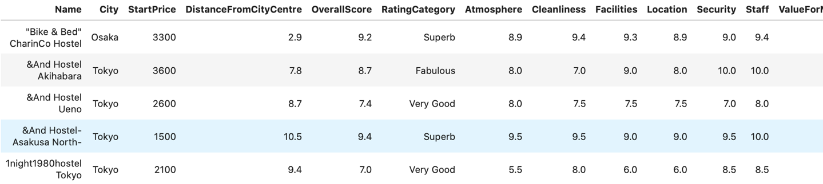Below is a snapshot of the dataset:

2.2 Hostel Neighborhood:

This dataset contains all the neighborhoods or venues within 500m radius of a Hostel. It has the following columns:

* HostelName: Name of the hostel
* VenueName: Name of the venue
* Category: It is the primary category of the venue, for eg. Café, Train Station, Restaurant.
* VenueLatitude, VenueLongitude: Coordinates of the venue.

Below is a snapshot of the dataset:

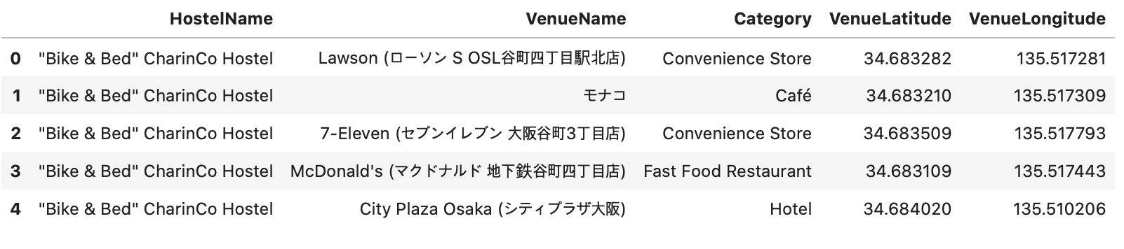

2.3 Tokyo Land Price:

This dataset contains the locality name and the average price of land per square meter. Below is a snapshot:

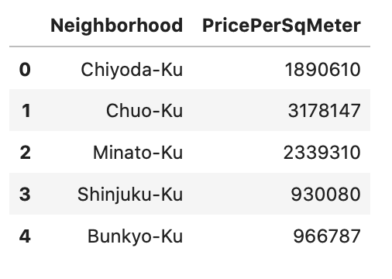

3. Methodology

3.1 Data Collection:

* The Japan Hostels dataset is freely available on Kaggle and was built by scraping Hostelworld.com website.
* We used Foursquare API to get the venues around the hostel.
* We scraped <https://utinokati.com> to get land prices of various neighborhoods in Tokyo.

3.2 Analytic Approach:

I took two approaches in the project.

Firstly, I used exploratory data analysis(EDA) to uncover hidden properties of data and provide useful insights to the reader, both future traveller and investor. I used the list of hostels from Hostel dataset and use Foursquare API to get venues around the Hostel. I will then use EDA to explore the neighborhood and how it affects the price of the hostel. I will also use the combined dataset to cluster similar hostels as per pricing and neighborhood.

Secondly, I used prescriptive analytics to help a business person decide a location for new hostel. I will use clustering(KMeans). I combined the above data with the land price for the area in which the Hostel is situated and them develop clustering models to predict where a new hostel should be opened.

4. Analysis

4.1 Exploratory Data Analysis

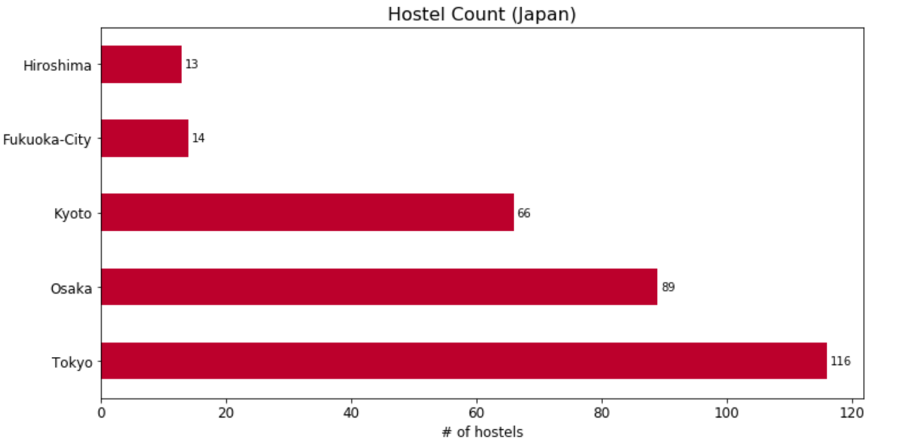First we tried to see how many hostels were present in our dataset per city.

Tokyo has the most number of hostels which is understandable since it is one of the largest cities of the world and hence might attract a lot of visitors. Also, the two airports in Tokyo make it an important hub in the pacific rim.

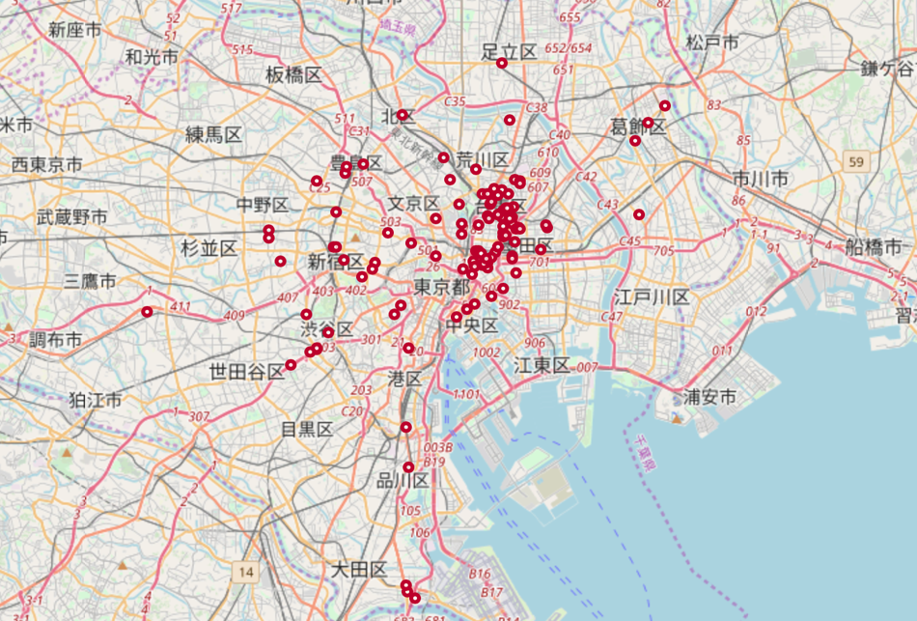Next, we visualized all the hostels on map using Folium and Open Street Maps. Below is the geo-visualization of the hostels in Tokyo. As we can see, many hostels are located near the centre with density reducing as we move away from it. In the report we have visualized the same map based on multiple criteria and clusters.

For a person interested in opening a new hostels, it is essential to identify the right area to do so. The main factors to consider while making such a decision is demand, supply and cost. Demand and supply usually go hand-in-hand in such cases i.e we can say that the more the

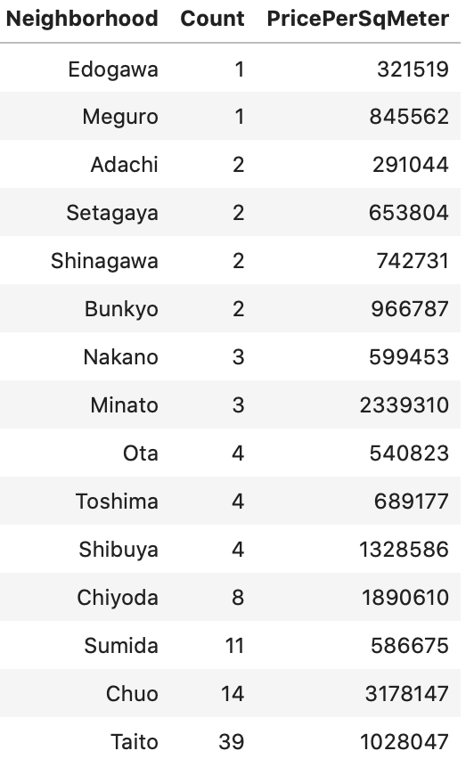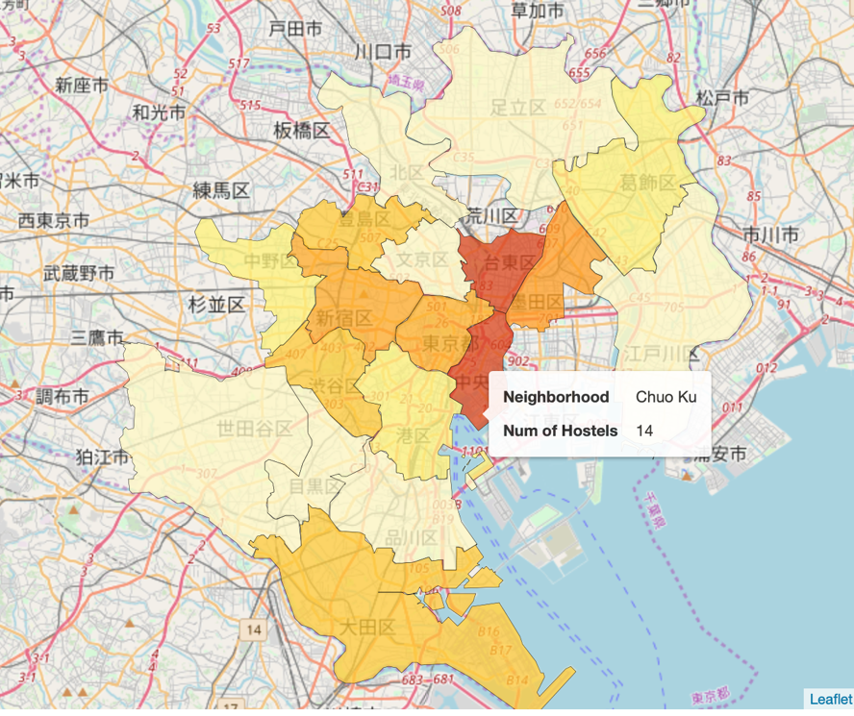

hostels in a region, the higher the demand. It is evident from the above map that **Taito** and **Chuo** are host to many hostels. Hostel density is highest in these neighborhoods. However, if we compare the land prices in these regions, they are amongst the most costly localities to buy property.

Sumida seems to be popular since it ranks third in the list of number of hostels and at the same time, it is the 4th cheapest neighborhood in our list.

The price of property(per sq. meter) in Sumida is almost 43% less than that in Taito, which combined with the fact that it is close to Taito and has fewer hostels than Taito, makes it an exciting prospect for new investors.

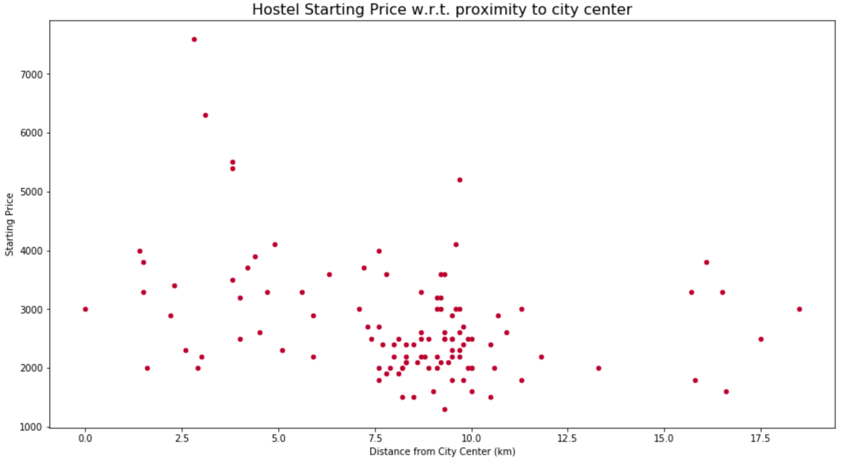Next, we checked if the distance of a hostel from the city centre has any effect on the price.

We can see a very weak negative correlation between the price and distance of hostel from city centre. Our intuition is supported mathematically by the Pearson coefficient which turned out to be -0.3. The correlation coefficient is very less to make any strong inferences.

Next we analysed hostels based on their “security” ratings.

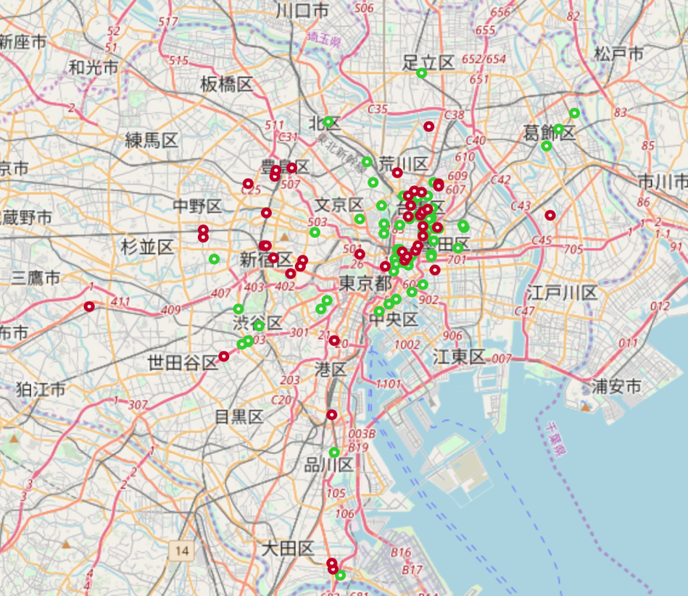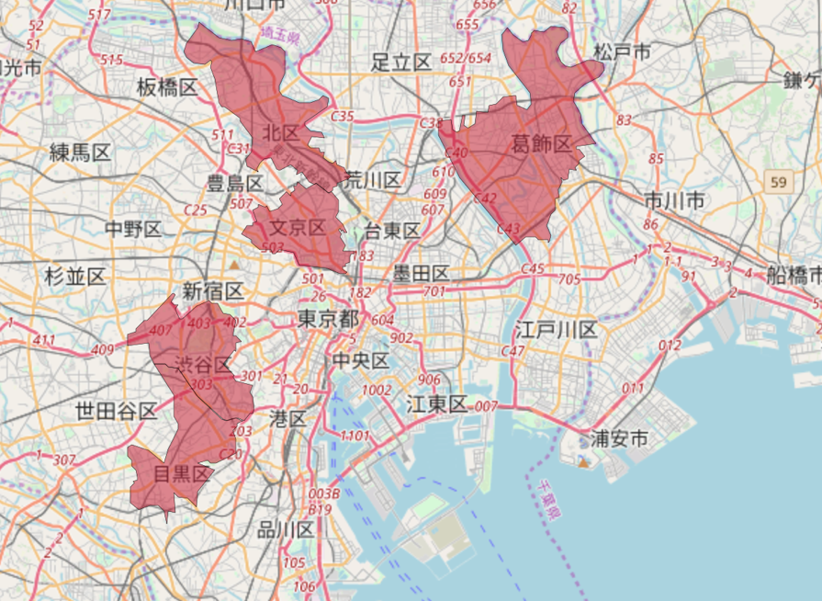

The diagram to the right shows the regions near Tokyo with the highest average “security” rating of hostels in that region. We can see, all such “high security” regions are located away from the city centre.

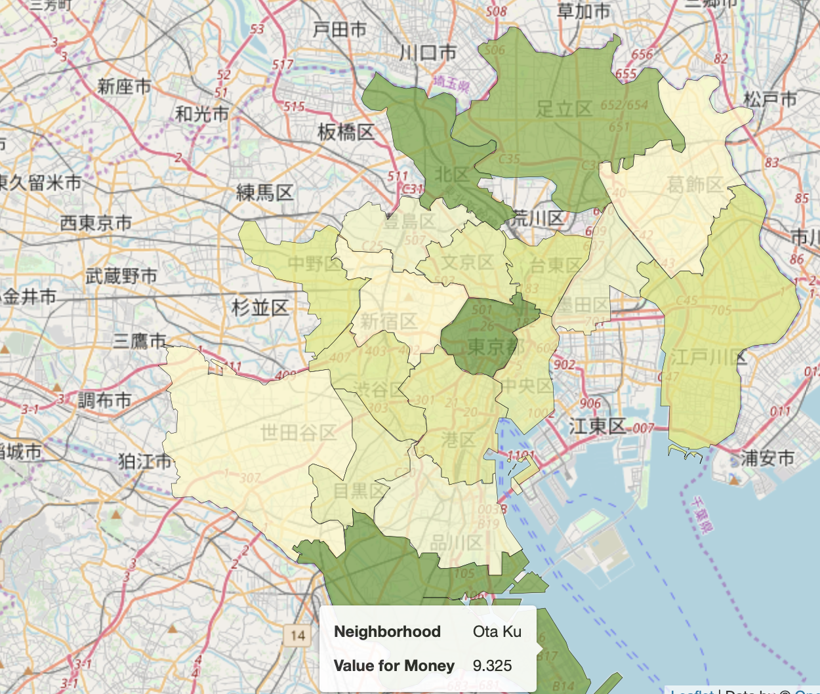Subsequently, we studies similar patterns in “value for money” rating and location of hostels.

There are no obvious conclusions that jump out here. Ota-ku and Taito have high average value for money rating which can be explained by the fact that Taito has many landmarks and tourist places, and Ota-ku is home to Haneda International Airport.

Next, we tried to see how does the neighborhood of a hostel affect its overall rating. Of course, this alone is not a strong predictor of rating, we aimed to find out some rough patterns. Following are the things we found out:

* Proximity to a mode of transportation seemed to greatly affected the ratings, since 50% of hostels near to a bus/metro station were rated Fabulous (highest rating)
* Proximity to convenience store did not have any effect.
* Hostels near museums and malls had a lower rating than the overall average. Only 25% of hostels in such areas were rated high compared to 32% overall.

4.2 Clustering

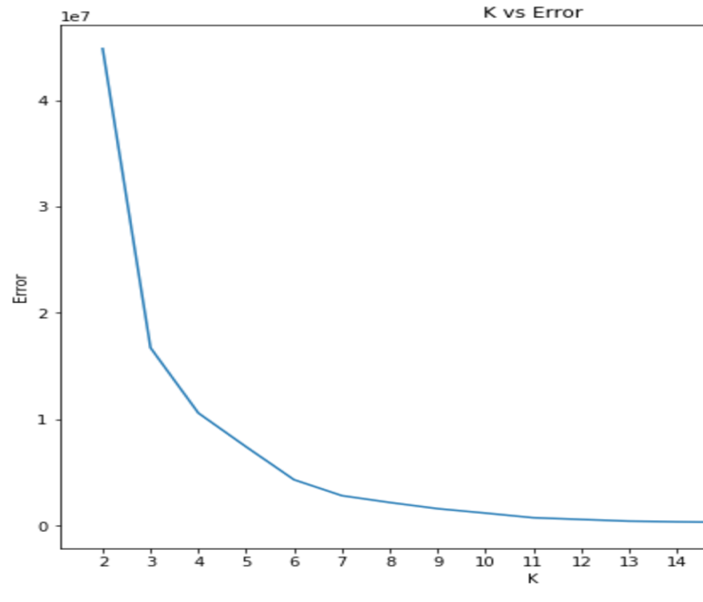We performed clustering twice based on different set of parameters. First, we clustered using the different rating scores, distance from city centre, and starting price. We used K-Means clustering algorithm and found out the K by using the elbow method. The K on our case is 6, since the error doesn’t decrease much after this point.

Let’s see a geo-visualization of the clusters and also examine the properties of each cluster.

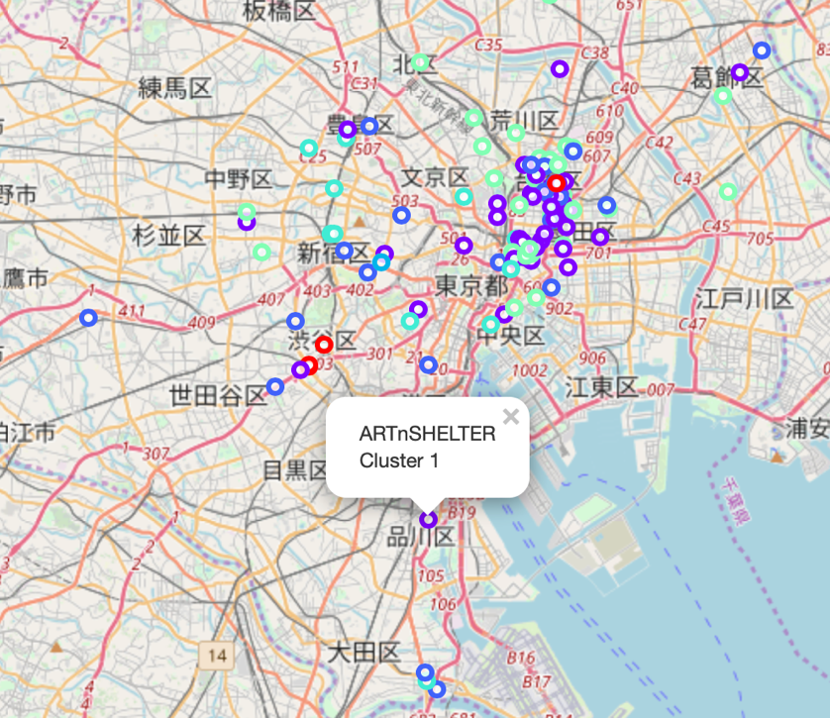

**Cluster 0:**

Very High Cost. Close to City centre. Very high cleanliness and security ratings

**Cluster 1:**

Medium cost. Far from city centre. High Value for Money score.

**Cluster 2:**

Low Cost. Average overall score between 8.5 and 9. Low atmosphere rating.

**Cluster 3:**

Low Cost. Close to city centre. Low facilities and staff score.

**Cluster 4:**

High Cost, On avg 7km of City center. All ratings moderately high

**Cluster 5:**

Very low cost. Far away from city cenre. High value for money and location ratings. Low

Second, we clustered the hostels based on the venues in its vicinity. This time, we fixed K in our K-Means algorithm to be 4 since otherwise each hostel would be assigned a unique cluster which defeats the purpose.

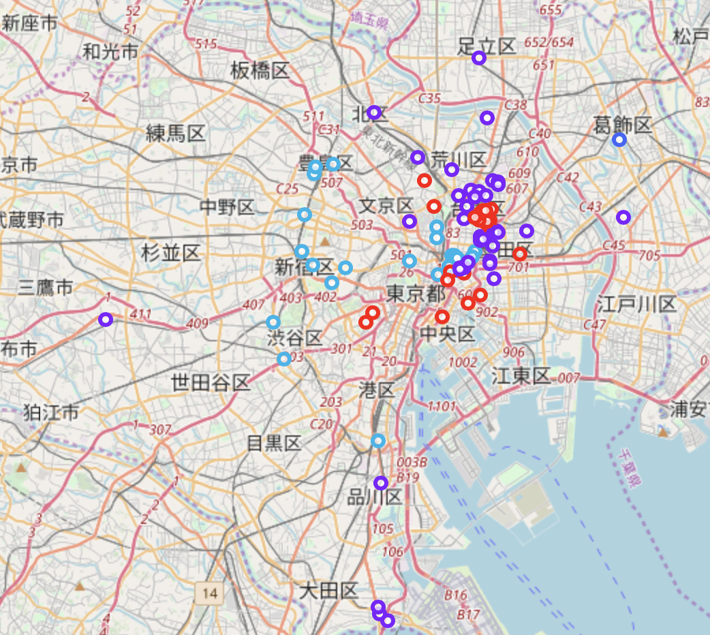

We can examined each cluster and determine the discriminating venue categories that distinguish each cluster. Based on the defining categories, we can then assign a name to each cluster.

|  |  |
| --- | --- |
| **Cluster Number** | **Cluster Properties** |
| **1** | Restaurants and Coffee Shops |
| **2** | Convenience Stores |
| **3** | **Baseball Field and Gym Pool** |

5. Result

We got a glimpse of the hostel scene in Tokyo and were able to find out some interesting insights which might be useful to travellers as well as people with business interests. Let's summarize our findings:

* Most hostels are located in Taito-ku and Chuo-ku.
* Sumida-ku seems to be an interesting locality since it is close to Taito-ku and 43% cheaper than Taito-ku.
* The starting price of hostels does not vary much depending on its distance from the city centre.
* Most of the hostels rated high for their security are in Katsushika, Kita, Meguro, Shibuya and Shinagawa
* Proximity to a mode of transportation or a historic site positively affects the hostel rating.
* Hostels rated highly for being value for money are comparatively cheaper and are located away from the city centre

6. Discussion

# TODO

7. Conclusion

# TODO